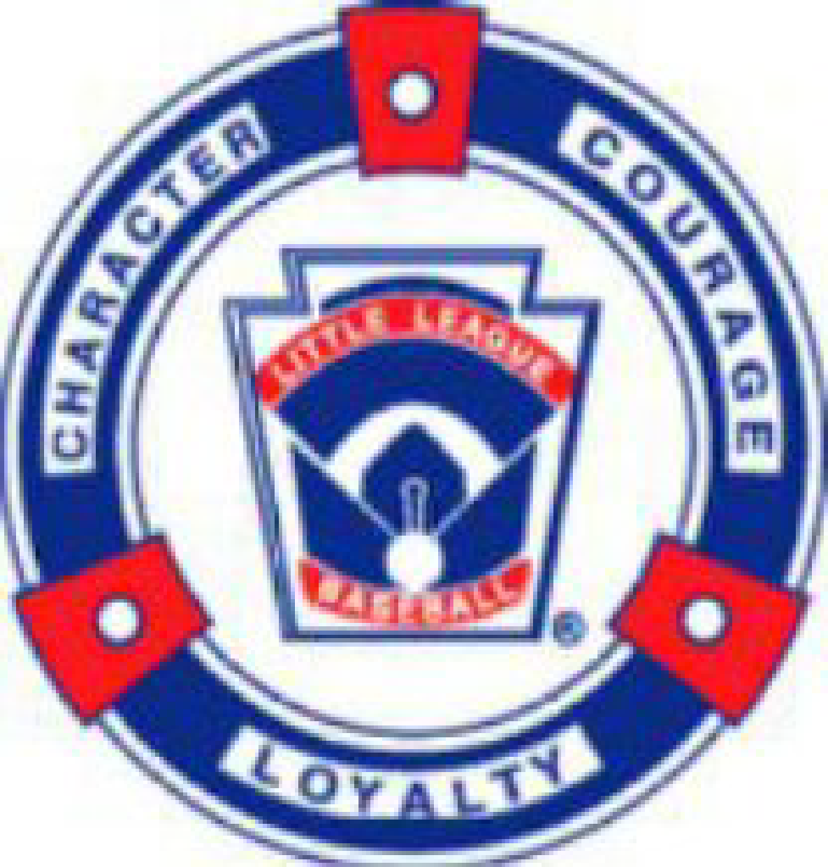

High Plains Little League (HPLL)
05/04/2025 Board Meeting Mintes

Attendees: Jeff Klimek, Gina Klimek, Jared Hotlz, April Standerfer-Holtz, TJ Hartley, Kristina Johnson, Jennifer Carlson, Ashley Carpenter, Kevin Carpenter, Jackie Reed, Brett Reed, Doug Ziegler. Dialed in Bobbi Lehman
Holtz House, Falcon, CO
05.04.1: Call to Order 4:05 PM
05.04.2: President Announcement After a lot of thought and consideration, we (April and Jared) will not be returning next season. By doing it know this will allow us to tie up loose ends and get everything organized for the next board to come in and be as successful as possible. We will give everything we have to finish out the season, All stars, and Challengers. They will not be running fall skills clinic but is someone would like to run with it we can support that. Jared will run final meeting in September to get someone new in. A statement will be made closing day as well in case someone wants to step up. Proud of what has been in done the last 3.5 years and we would like to pass it off and not see it fall.
05.04.3: Meeting Minutes Sent via Teams for approval for 4/09/25 - responses for majority approval.
05.04.4: Treasurer update (Gina):
- Current account status: ENT and Farmers
  - Balance:
    - ENT: $111,139.08
    - Farmers: 6380.00
  - March’s information is ready and will be passed off to audit committee, nothing believed to be missing for March.
  - Petty cash: $70 being kept in the petty cash for the concessions stand, anything more has been deposited and will continue to be deposited.
- 990EZ Updates
  - Becky has submitted 2023, last steps in the works to get 2024 to finalize and then we will be fully caught up on taxes.
- To Do List: Working Budget, State Sales Tax Exemption, Bingo/Raffle License
  - Still working on the sales tax exemption and bingo/raffle license.
  - Need to tally numbers against budget to see where we are at. If anyone has their individual amounts on their budget and can send it to Jared that would be helpful
05.04.5: Facilities
- FMS Backstop
  - D49 says they will be repairing it; several people have reached out about it and even offering to fix it but we are trying to allow D49 to fix that.
- 5/31/25 Lights Approval at FRP
  - If we break sprinklers or anything HPLL will have to repair them.
- UC Health Park Challenges for make-up JR’s games
  - Trying to get schedule with Vibes but there are some schedule changes with the Vibes so they might not be able to make it happen.
  - Bobbi said she can reach out to CSLL to see if they would let us borrow Wasson for two-night games, Doug said what about UCCS, Bobbi said if you can get them to respond we can try. Brett suggested Spurgeon Park it has lights. Bobbi said she has a contact with the city she could reach out to as an option.
- PLC fence still needs to be dug right now it has pool noodles on it. It is felt it’s a lot to fix it and it’s a D49 issue to fix. The 3rd base dugout gate is busted and there is sharp pipe sticking out.
- The county will still be box grading FRP and will work on the lip on white field.
05.04.6: Softball Update:
- Open for Ashley Discussion as needed
- Trying to get games set with Cherry Creek and Arapahoe as they each have only one team, them come down and play double header and us go up there to play a double header. Ashley offered May 18th to play our fields that morning with a double header with the Bisons if Eagles are available, we will need an FRP field.
  - Bisons parents are all in for the May 18th
  - Chris, the District 5 Administrator did say we can play in June with the All-Stars team as a scrimmage for us but a game for Arapahoe.
05.04.7: Equipment (Jeff):
- Budget update
- New Equipment bag discussion, new bag are in as equipment comes in it will be moved to the new bags and we will meet with all start coaches to swap their old bags out so they have the new ones for all stars
05.04.8: Umpires and Scheduling:
- Umpire plans, Status, Updates (Doug)
  - We will start using our umpires for Juniors so we will not need to use Rocky Mountain for them any longer. Denis is volunteering his time; Doug would like to compensate him some way.
- Scheduling: Status of reschedules/end of season tournaments
  - Working on T-ball moving to 1-hour games so we can play two games a night to avoid Sunday reschedules.
  - Minors and Majors are pushing into Sundays for reschedule.
  - It was asked if there is room to go later on Saturday, Bobbi said coaches don’t want to do that because of pitching issues for both minors and majors. Jared said we may need to tell them they will be playing double headers because it’s what we have available.
  - It was asked if coaches say they won’t play but others will can we just pair the ones they will together. Jared said yes, we can.
  - For interleague we have had mostly success in reschedules and that due to schedule conflicts some did not get reschedule
    - Panthers only have 12 on the books their 13th and 14th were interleague and got cancelled.
  - CSLL got put on warning for their teams no call no show. Bobbi has reached out to them but gotten no response.
- Next year Bobbi is going to see if it’s possible to stagger sibling games. Doing certain days for divisions would help.
- End of season tournament
  - Softball will start May 27th.
  - Baseball Minors will start May 29th or May 30th. Juniors and Majors will start the following week.
  - Need to discuss in more detail if we can pull of an interleague end of season tournament, for baseball its felt we would stay in house. Everyone agreed to keep Softball and Baseball tournament in house.
- Ashley said CSLL is getting worse and worse to work with on their softball side. There have been issues with scoring and other things.
- April asked if last games t-ball and rookies could be June 1st so Jared and April can both be there to hand out medals. Bobbi can try to get all games in by June 1st she can look at the schedule. April said if we can try by the June 4th that would work.
05.04.9: Events:
- Opening Day: Needs/Status
  - Jared will reach out to find someone for a prayer
- Rockies Day: Needs/Status
  - Email sent out 5/4 with order forms to all families.
- Vibes Day: Needs/Status
- Golf Tournament: Separate Meeting TBD to get together
  - Kevin will be going around to get prizes for the raffle.
04.09.8: All Stars Discussion:
- Tryouts dates and times 5/16-5/17
- Player nominations due by 5/9, coaches have already been told of this date.
  - Number to nominate differs per division based on how many players are in the divisions.
- Jared, we need to have an open discussion about the option. Criteria those that will rep high plans at the highest level, look at the competitively state also but more who will rep us the best
- Manager Decisions: Discussion and Voting
  - Juniors Baseball
    - Interested Coaches: Phil Blundo, Adam Smith, Dave Sevier
    - Voted/Approved: Dave- Jared motion, Gina second, all agreed none opposed
  - Little League Baseball
    - Interested Coaches: Shaun Piontek and Mike Hodges
    - Voted/Approved: Shaun- Jackie motion to approve, KJ Second, all in favor, none opposed
  - 8-10 Baseball
    - Interested Coaches: Red Carlson, Jared Holtz
    - Voted/Approved: Jared- Ashley motioned, Gina Seconds, all in favor, none opposed
  - Juniors Softball
    - Interested Coaches: Ashley Carpenter
    - Voted/Approved: KJ Motioned, TJ Second, all in favor, none opposed
  - Little League Softball
    - Mandy Morrow, Doug Ziegler
    - Voted/Approved: Mandy- Doug Motioned, Ashley Second, all in favor, none opposed
- Tournament Hosting and dates: Updates
  - Juniors Baseball
  - Little League Baseball
  - 8-10 Baseball - HPLL
  - Juniors Softball-HPLL
  - Little League Softball
  - Jared was asked at the district meeting if we would host intermediates. Discussed hosting intermediate, all voted to not host as we are already hosting two.
  - The remaining hosting locations are TBD
- We will be spending less money this year, Last year we ordered pins so we don’t need to order, we need to check if we have enough LL packages. Don’t need to order Hats for tournament or extras for all-star parents as we have them from last years.
04.09.9: Open Discussion
- Next Board Meeting Date - Holtz House June 9th 6pm
- Open Discussion
  - Jerseys- They are in the team chat need to vote on the $50 or $60
    - $60- April motion, second TJ, all in favor none opposed.
    - Color- White jerseys with navy paints- Jackie motions, TJ Seconds- all in favor none opposed.
  - Tech Tees- $30 we paid $28 last year, it’s an additional $6 to upload our own logo.
    - Pay the additional $6- Brett mentions, Gina Seconds- all in favor none opposed.
  - Managers will be notified for all stars to nail down try outs times. Assistants will need to be picked by Tuesday May 6th

Meeting Ended 6:19 PM

